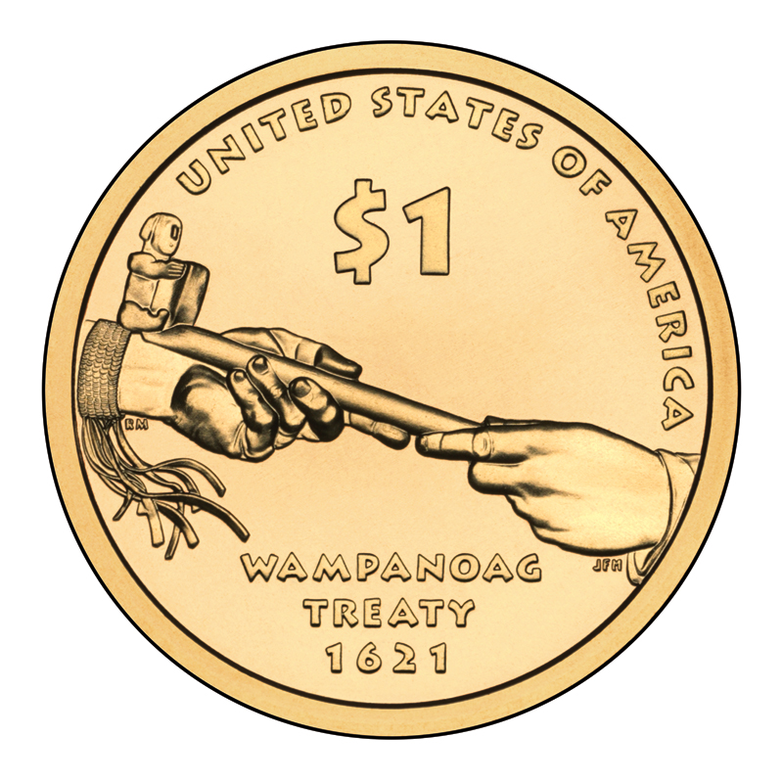

SOWAMS NATIONAL HERITAGE DISTRICT
ROUGH DRAFT PROPOSAL 4-14 HHT

- Establish a Sowams National Heritage District throughout the traditional Pokanoket homeland of Sowams within Rhode Island and Massachusetts.

- Provide a framework for engaging the nation in appreciation for this place of Sowams and the Pokanoket Tribe in the heritage of our country.

- Conserve essential cultural, natural, scenic, historic and recreational open spaces of Sowams for all people, for all time.

Why should we do this?

The place we live is an essential part of who we are as people. Fully appreciating Sowams past and present is invaluable to us individually, to our communities and to our country. Communicating and passing on this understanding is the only means to protect this place and perpetuate its values for future generations.

It can be argued that Sowams is the pivotal place of cultural exchange between indigenous people and colonizing settlers in North America. Few people realize that there was a treaty between the Pokanoket Tribe and the Puritans established on March 21, 1621. This peace treaty stood for over 50 years before it was broken during the conflict known as King Phillip’s War in 1675. The initiation and duration of the peace is unique among the colonial patterns of interaction across the New World. The human toll of the eventual conflict was the costliest to its respective populations. The impact of the outcome of this clash of cultures continues to this day.

National recognition is given each year to Plymouth and the settlement struggles there. But our modern traditions of a national Thanksgiving celebration truly arose from the traditions of the people of Sowams. The property that could best express this heritage and contribute to a rebalancing to our commemorations lacks permanent protection and has limited access. Potumtuk, in Bristol, includes King Phillip’s Seat and the spring where he was killed. Establishing a heritage district could contribute to our awareness of history and intercultural tolerance. Conserving Potumtuk would be a positive step in healing our nation with a rededication of this land as a place of peace.

Why should we do this now?

The region of Sowams includes some of the most densely populated parts of the country. For example, Bristol County, Rhode Island is the smallest county in the United States based on acreage and includes three towns, Bristol, Warren and Barrington. Land development pressures on the remaining open areas are high, especially with the rebounding economy. If key places are not protected within the next decade, the opportunities for protection may be greatly compromised. A timely campaign could insure that the Sowams Heritage District is well established before the 400th anniversary of the peace treaty between the Pokanoket Tribe with the Puritans in 2021.

What are the benefits?

Establishing a heritage district and gaining recognition at a national level would provide a framework for communicating and celebrating the region. Many special places within Sowams have already been protected. The district project could provide the needed boost to achieve protection for identified key properties and to compete for acquisition funding. It would be a source of pride for residents and a draw for visitors. Everyone would benefit from a greater understanding of the natural and cultural history of Sowams and access to the enjoyment of areas that have been protected.

What are the challenges?

It will take a coalition of partners to accomplish establishment of the district and protection for key remaining parcels. It will take public outreach and education to raise awareness about the benefits of a district and to raise awareness of its proper place as a national district with sites of an international caliber. A cooperative and positive tone will help insure that all partners can be seen as contributing to this worthwhile effort benefiting current and future generations.

Why utilize the district concept? Flexibility, Scale, ‘Branding’ and Cost

Flexibility suits an area that is already quite developed with many layers of history, strong local traditions and a patchwork of opportunities…and a variety of ownership. The Sowams Heritage District can include sites with both variety and a multiplicity of features: open spaces, scenic views, historic sites and recreation - all contributing to the strong sense of the place that is Sowams. You would not fully experience this region without these complimentary aspects. Flexibility also applies to the themes that can shift to meet the times such as fitness through walking outdoor trails or themed sidewalk routes across the district.

Scale is critical in achieving a regional perspective and in engaging partners in an effort bigger than any one of our modern day communities. Working together should help to secure more resources – talent and funding - than would be available at a more localized level. As the district project builds momentum, it should be possible to add more partners, including local businesses, and to broaden public support.

‘Branding’ of the district will be a tool in unifying the diverse district features and communicating to many audiences about Sowams. With a clear message verbally and visually, recognition will grow to assist in the protection efforts, enjoyment of resources and to sustain the concept for future generations. Some of the early steps in establishing the district can be taken at a relatively low cost and low effort, by recognizing the places and features already protected as a part of the district. The district could develop a ‘sponsorship’ program to help fund its work.

A district approach could also be cost effective. Materials and maps can be provided online along with social media supporting district activities and fundraising. If featured properties are fully protected, the ownership could remain the same with perhaps a district conservation easement added, as needed. Properties that are already fully protected and managed by individuals, partner organizations and local and state governments can be included under the district label while incurring few additional resources from the district itself.

Conclusion

The purpose of this brief document is to provide a draft outline of the Sowams National Heritage District concept for consideration by the Road Map RI project of the RI State Department of Administration and Planning and to encourage thinking about this possible tool for land protection and public and partner involvement and the benefits a district could bring.

How can I support this effort?

Sign up for information and meeting notification by providing your name and email to Helen Tjader, helen@acornnpsolutions.com Interested in hosting a presentation or informational meeting, call Helen at 401-480-8329.

